DNS SERVER CONFIGRATION

- take snapshot

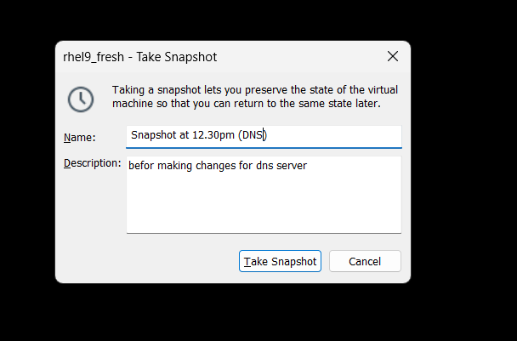

2.Configure network (SET IP 192.168.0.100 ) (SET HOSTNAME AS DNSSRV.RADICAL.COM)

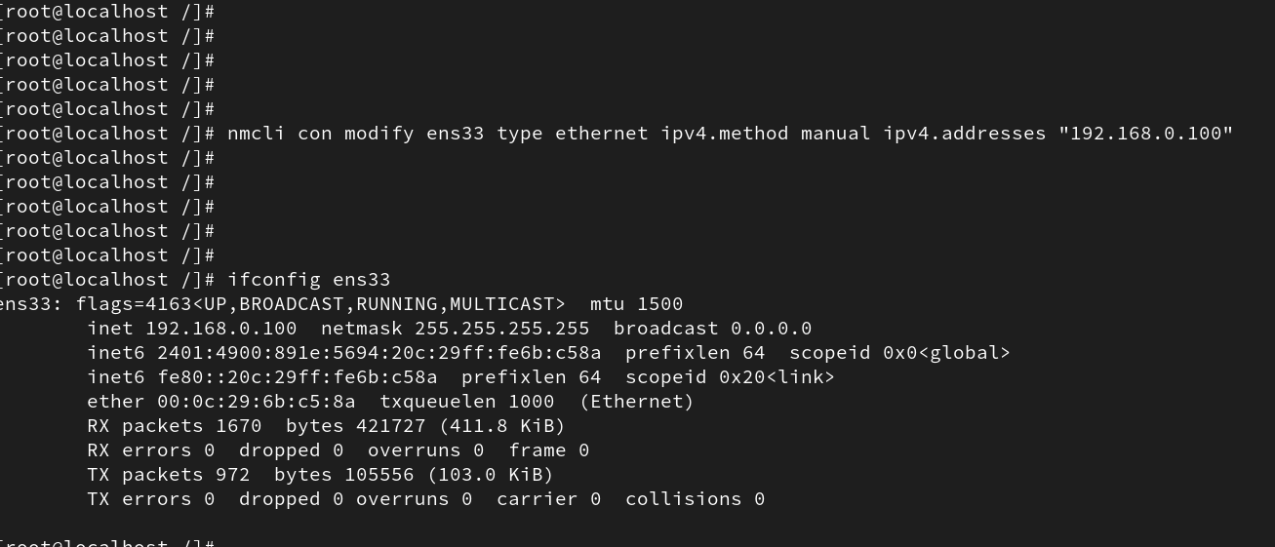

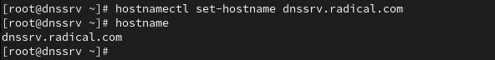

3.Make entry in /etc/hosts

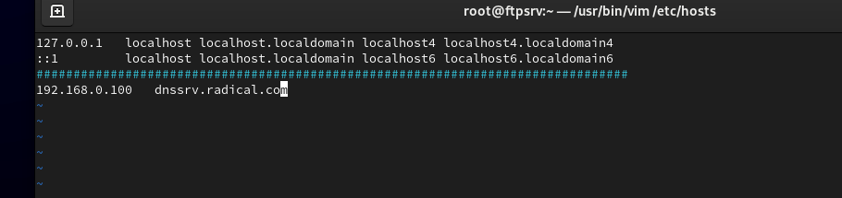

4.install required package

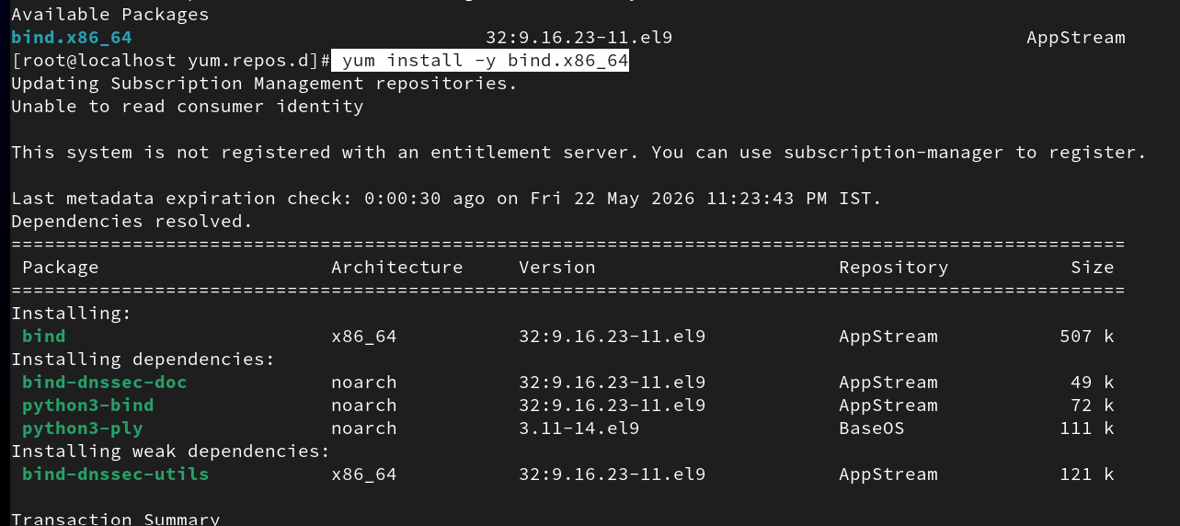

5.find configuration files
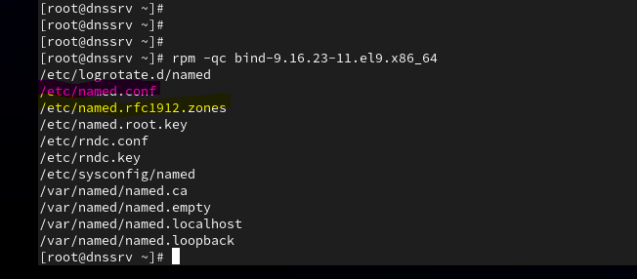

6./etc/named.conf=This is the main configuration file of the DNS server.
Used for:
• Port (53)
• Listening IP
• Allow query
• Directory paths
• Security options
listen-on port 53 { 192.168.0.115; };
allow-query { any; };
This is daemon configuration only.
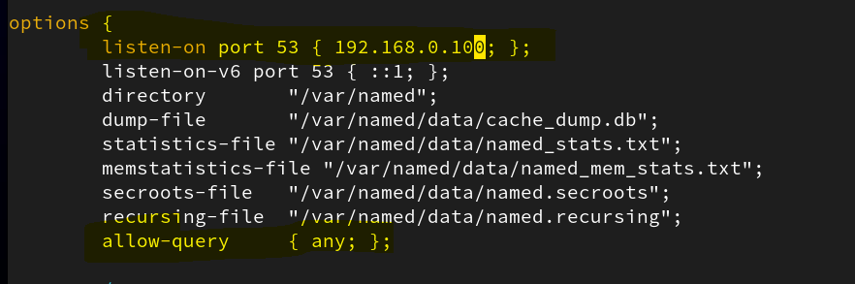

Synatx for error checking of confi file :
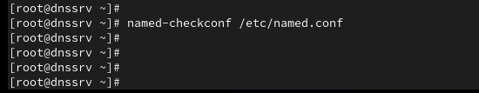

7.Declare Zones

You will declare zones in:
/etc/named.rfc1912.zones

What you need to do next:
1) Open zone file configuration:
vi /etc/named.rfc1912.zones

2) Add your zones.
Forward zone =A forward zone is used to convert a domain name into an IP address.

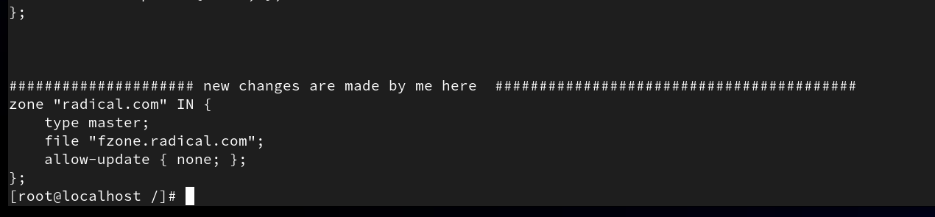

8.setting in fzone.radical.file =We copy content from named.localhost or use its format to create the forward zone file because it provides the basic DNS zone structure like SOA and NS records.
These settings are used to define the authority of the DNS server and to map domain names to IP addresses in the forward zone.

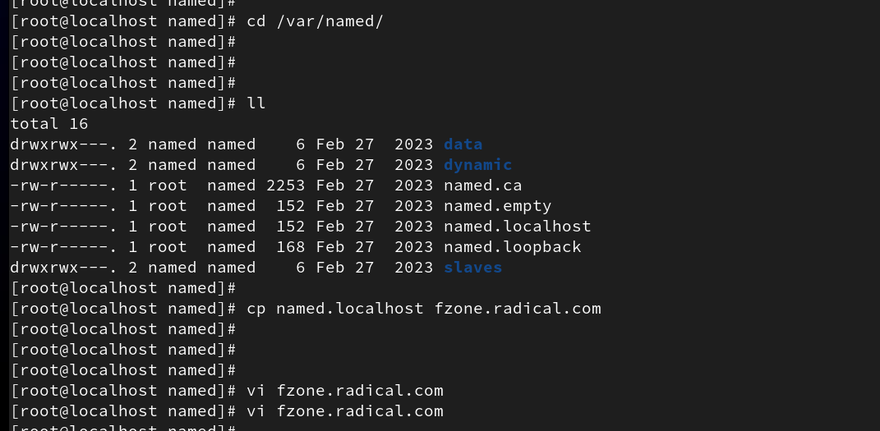

MAKE CHANGES INSIDE FILE
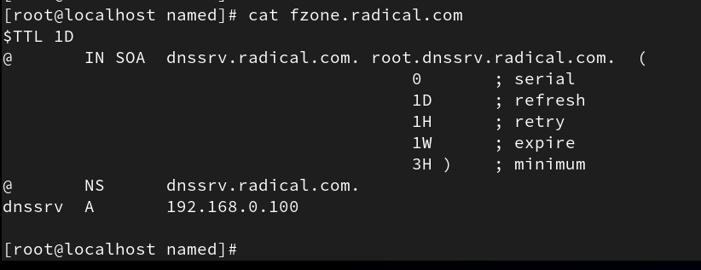

9.syntax error checking for forward zone 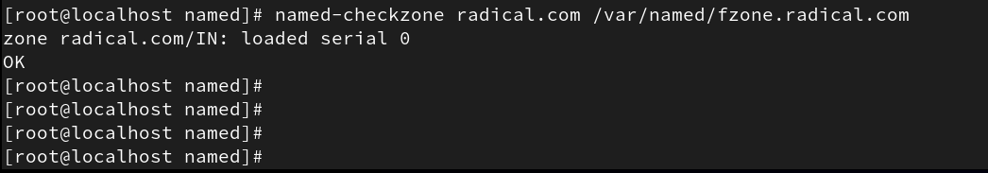

10.After making changes in DNS configuration files, restart the named service to apply changes.
Enable the service so it starts automatically after reboot.
And check logs
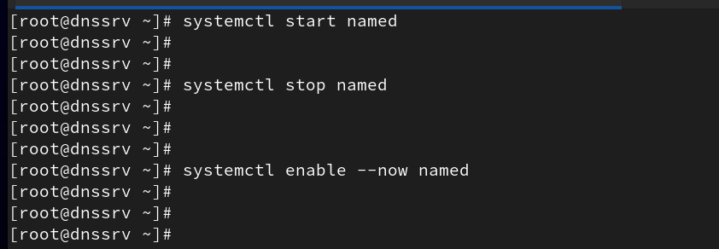

11.Temporarily disable SELinux for troubleshooting

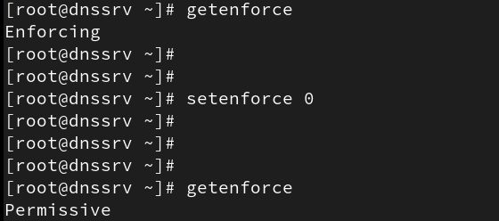

12.allow firewall
To allow DNS requests through the firewall, execute the following commands:
firewall-cmd --permanent --add-service=dns
firewall-cmd --reload
And restart service again
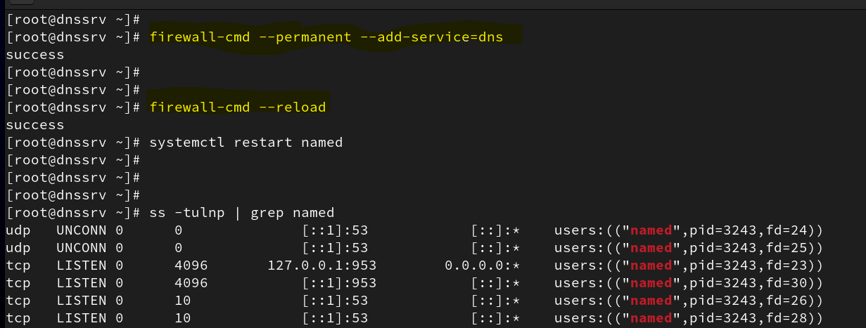

13.Client side config
Ip in same range ,
Should ping its own ip,
and ping servers ip

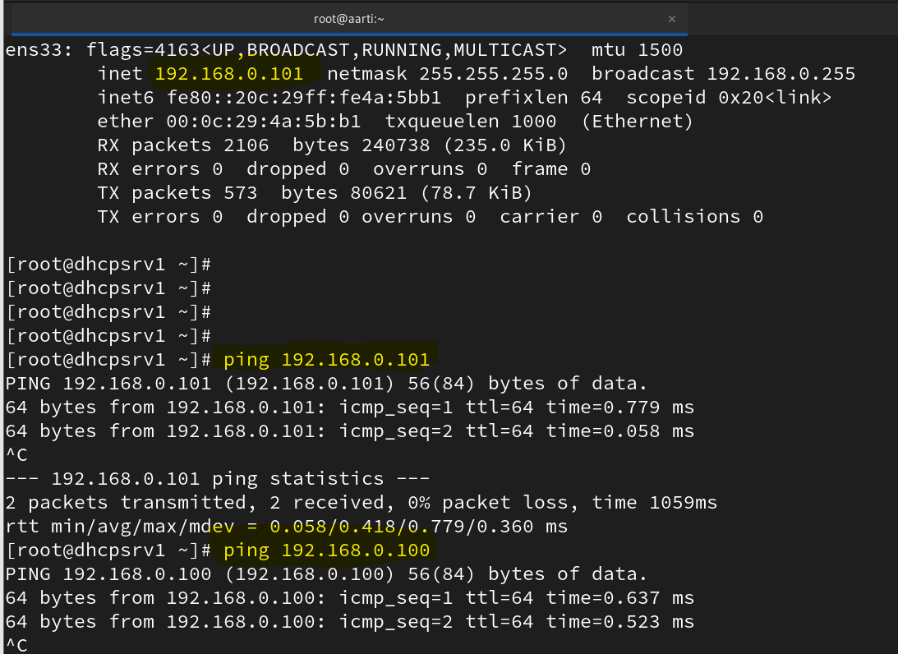

- Client DNS Configuration

Check DNS configuration file on client side:
cat /etc/resolv.conf

The file should contain:
nameserver 192.168.0.100

This means the client system is using the DNS server with IP address 192.168.0.100 for name resolution.

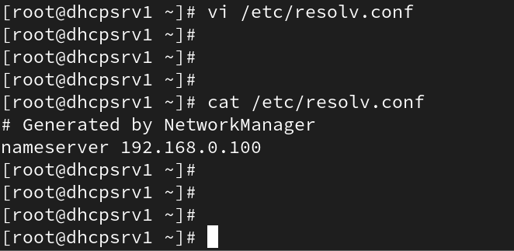

- Name resolution started working successfully from the client system.

